Washington Parish Council
Winter Management Plan 2025-26

Point of Contact during office hours:
Clerk to Washington Parish Council
Office hours: Monday-Thursday 9am-1pm & 2pm-5pm (except bank holidays)
E-mail: clerk@washingtonparish.org.uk
Website: www.washingtonparish.org.uk
Phone: 0777 6771921

Alternative Point of Contact:
Chairman of the Parish Council: Cllr Tony Lisher
E-Mail: tonylisher@washingtonparish.org.uk
Mobile Tel: 07710 600187

WSCC Treatment Coverage

WSCC have undertaken to fill any grit bins that are located on the public highway before winter.

After the initial fill the Parish Council on 3 working days prior notification from residents/members of the public that the bins are half full or less will arrange to re fill these grit bins where possible.

WSCC grit bins are located at:

Stocks Mead, The Holt, The Street, The Franklands Arms, Chanctonbury Close, School Lane (Village Hall Car Park), The Subway, Newhouse Lane, Merrywood Lane, Thakeham Copse.

WSCC have undertaken to maintain the following network -

WSCC’s Precautionary Salting Network - A283 through the Parish; A24 through the Parish, Rock Road through to the junction of the A24, Washington Bostal, The Pike.

For on line details please see: http://www.westsussexhighways.org/pages/winterroads ; http://westsussex.cdmf.info/incident/map.htm (click on the grit bin lorry icon)

WSCC will make the decision whether to salt all or part of the precautionary network daily between the 1st October and 31st April based on all available information. Information on the decision is available on Twitter @WSHighways.

Alternative contact details - ced.rural@westsussex.gov.uk
Please note that the salt provided by WSCC is for use only on public roads and footpaths.

Washington Parish Council Salting and Clearing Arrangements

After the initial fill of bins as identified above all further fills will be carried out by contractors instructed by Washington Parish Council where the grit bins are half full or less within three working days of notification by residents/members of the public where possible.

- All Parish Grit bin locations: Sandhill Lane, The Street, School Lane, The Holt, Chanctonbury Close, Franklands Arms Car Park, Stocks Mead, Montpelier Gardens, Spring Gardens, Merrywood Lane, Newhouse Lane, Thakeham Copse, Thakeham Copse, Blueberry Hill, Bracken Close, Bracken Lane, Vera’s Walk, Sanctuary Lane, Hazelwood Close, Bracken Lane, Georges Lane (pine Cottage), Georges Lane (Ridgeways), Badgers Holt.

- Bulk bags of salt to be delivered by WSCC Highways to or collected by a named local person prior to the commencement of winter for storage and distribution to the Parishes grit bins when instructed by the Parish Council.

Hippo bags to be delivered to:
Andrew Luckin, Weavers Cottage, The Street, Washington, RH20 4AS (yard behind cottages). Who will manage grit bins located in Washington Village and lanes east of the A24 – 07793 414809
Joseph Payne, Joseph M Payne, MM Enviro Ltd, Barn Cottage, London road, Washington West Sussex, RH20 4AZ,– who will manage grit bins located in Heath Common, Rock Road, Subway and Montpelier Gardens - 07788 426931

Public Liability Insurance sufficient for both parties

Road and Footpath Clearance Volunteers

Washington Parish Council will not be using the assistance of Volunteers or providing indemnity for gritting, footpath and road clearance and any person using grit and/or the grit bins provided by WSCC and /or Washington Parish Council does so at their own risk.

The attached information on the safe handling of salt and grit is provided for information only.

Washington Parish Council has identified the following problem areas:

School Hill, Washington - wet and icy during the winter - School drop off area on a hill.
The Street, Washington – residential street on a hill – prone to icy conditions
The Old London Road (former Chardonnay Restaurant to Rock Road), Rock Road and The London Road / The Bostal.

Emergency Plan

Councillors are requested to check residents’ needs in their nominated areas and to refer offers of help to the Chairman, as co-ordinator or any other person nominated to act as such on this document.
In extreme weather conditions, the Emergency Plan will supersede this Local Winter Management Plan.
If you are aware of particular hazards, you are welcome to contact the Chairman of the Parish Council or the Clerk.
If there is an immediate danger, contact the Police on the non-emergency number (101) or in a genuine emergency 999.
Advice on hand salting (WSCC)

The photographs below illustrate some of the key features of effective hand salting.

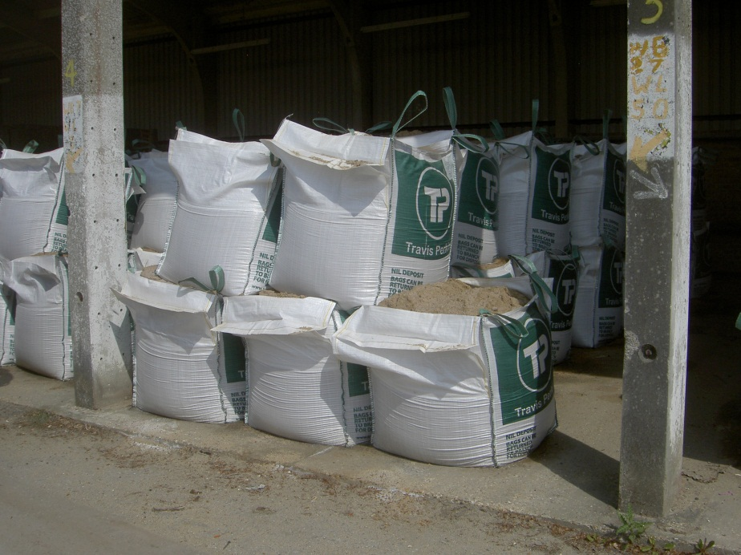

Bulk Bags
One ton bags of salt / grit mix delivered to agreed locations as a response to a prolonged snow event for use on the public highway as a form of self-help. This material is not for use on private land.

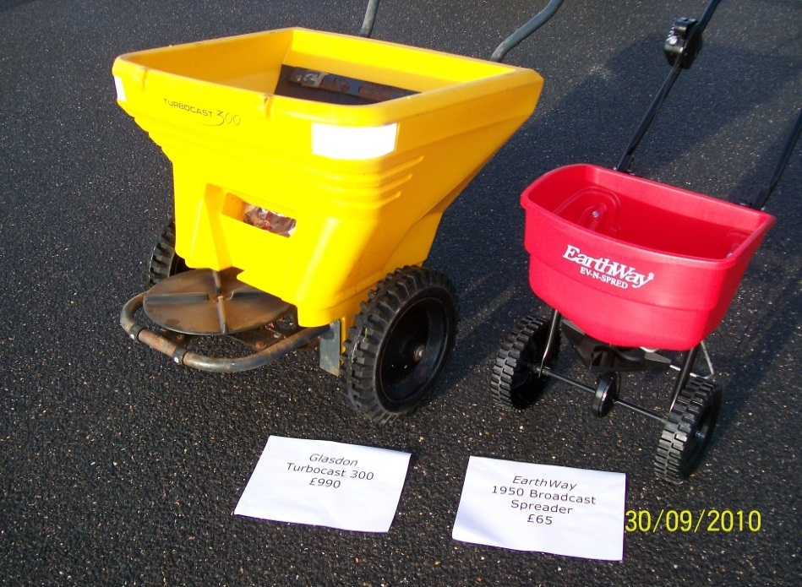

WSCC recommends a spread rate of approximately 20 grams of salt / grit per metres square when hand salting. Although salt / grit can be spread effectively with shovels, care is required to ensure over salting does not occur. Push-along devices as shown above can be used to cover larger areas with an even spread. Large areas can thus be treated quicker with less wastage.

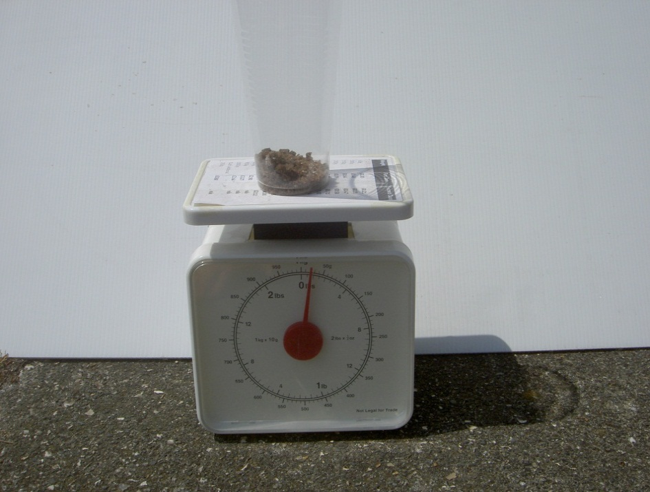

20 grams is in fact a very small amount. You don’t need a lot of salt to protect a footway. Use it sparingly. Over salting is damaging to the environment and a waste of a limited resource.



The white board in the above photo is one metre square and has 20 grams of salt / grit spread across it. You will observe that you do not need a lot of salt to protect the footways. Spread it evenly and your salt will last longer and cover a greater area.

Washington Parish Council

LOCAL EMERGENCY PLAN 2025/26

PROLONGED LOSS OF POWER/SIGNIFCANT FLOODING
In the event of prolonged loss of power or significant flooding, the Washington Village Hall can be made available as a central meeting place or refuge for residents of the parish.
Address: School Lane, Washington, West Sussex, RH20 4AP. Contact details for the Village Hall: 0774 786 0592 – Email: helentwine@wasahall.co.uk

FLOODING
In the event that extreme weather is forecast, volunteers and members of the public should monitor weather reports and warnings by the Environment Agency to assess the likelihood of flooding.

EXTREME SNOW
In the event that extreme weather is forecast, volunteers and members of the public should monitor weather reports and warnings. West Sussex County Council are responsible for keeping roads and highways clear. Grit is provided for use by members of the public on pavements, but should not be used for private paths and driveways. Please look out for and/or call upon elderly and vulnerable neighbours to ensure that they are warm and well. When shovelling snow, please have regard for your own safety and the safety of others.

LOSS OF POWER AND/OR FALLEN TREES
Care should be taken to ensure personal safety at all times. Fallen power cables should not be approached. Only those qualified to use a chain saw should work to remove fallen trees and restore access routes.

ACCIDENT / CASUALITIES
In the event of an emergency dial 999 in the first instance. A First Responder may be the first to arrive and will bring emergency equipment with them.

A DEFIBRILLATOR is available for use by the public. One is positioned on the outside of WASHINGTON VILLAGE HALL RH20 4AP and another at PIXIE’S CORNER, HAMPERS LANE RH20 3HY. The defibrillator pack contains instructions for its use.

Care should be taken to ensure personal safety at all times. Be aware of hazards i.e.. traffic, risk of electrocution, danger of broken glass, leaking fluids, gas etc.

Emergency Contacts:

Contact during office hours/Parish Council
Mon-Thurs 9am-1pm & 2-5pm (except public holidays)
Clerk to Washington Parish Council
Tel: 0777 6771921
Email: clerk@washingtonparish.org.uk

Local Contact for Washington Parish Council
Chair of the Council Cllr Tony Lisher, Dera Doon, Georges Lane, Storrington, West Sussex RH20 3JH.
Tel: 07710 600187
Email: tonylisher@washingtonparish.org.uk

UK Power Networks – Call 0800 3163 105 or 105 if you are in danger, notice any damage to their equipment, or are unable to use their online services.
Website and latest updates: http://www.ukpowernetworks.co.uk/internet/en/contact-us/power-cuts-and-emergencies.html

Southern Water – 0330 303 0368
Website: https://www.southernwater.co.uk/help-and-support/

Environment Agency incident hotline: 0800 80 70 60
Website: https://www.gov.uk/report-an-environmental-incident

Floodline helpline: 0345 988 1188 (7 days a week/24 hours a day)
Website: https://check-for-flooding.service.gov.uk/

National Gas Emergency Service – 0800 111 999 or textphone (minicom) on 0800 371 787
Website: https://www.nationalgas.com/emergency-contacts

Red Cross (Kent and Sussex) Provides central mobile catering facilities for communities without power.
National Helpline (General enquiries): 0344 871 11 11.
Support at Home: Tel: 0800 028 0831
Website: https://www.escis.org.uk/get-online/british-red-cross-kent-and-sussex-brcs/
Red Cross: Prepare for emergencies | British Red Cross

National emergencies - https://www.gov.uk/terrorism-national-emergency/national-emergencies

Date of review | Minute reference | Date of next review
13th May 2024 | APCM/26/14 | May 2024
12th May 2025 | APCM/25/5/20 | May 2025

